**ALLAM - Hulum**

By:

Salma Bamasoud

Heba Al-Hyasat

Lujain Asfour

1. **Introduction**

"Hulum" is an application’s goal is to help young children, aged 4 to 6 years, in learning Arabic language through creating a fun and engaging learning environment, such as interactive stories and exercises. Specifically, Hulum’s objective is to guide children through asking questions, providing feedback, offering encouragement throughout their learning process. In fact, Hulum’s goal extends beyond teaching Arabic; it also aims to build children's confidence, self-esteem, and cognitive skills within a playful and engaging environment.

**2. Related Work**

Previous applications aimed at teaching Arabic language to young children often rely on static content, such as pre-recorded audio and fixed text exercises. Several Arabic learning apps focus on language fundamentals, but few employ AI to create personalized and dynamic content. Moreover, existing tools often lack engaging visuals or interactive elements, which are crucial for catching young children’s interest. As future plan, "Hulum" will be using AI to offer personalized learning and adaptive paths tailored to each child’s educational need; for instance, Hulum should be able to process children’s feedback in order to tailor more specialized exercises based on their needs.

**3. Project Scope**

The app will begin by engaging children aged 4 to 6 with foundational Arabic skills, focusing on letter recognition. Over time, it will expand to include more advanced language levels. Each child will be greeted by name, creating a personalized experience, and will interact with the app through stories and exercises tailored to their individual learning stage.

**4. System Requirements**

**4.1 Functional Requirements**

* User Interaction: Children will interact with the app by touching the screen or speaking with the application.
* Custom Content: The app will generate stories and games tailored to child’s age and learning level.
* Feedback and Guidance: The app will provide instant feedback on the child’s answers, offering encouragement when needed.

**4.2 Non-Functional Requirements**

* Performance: Responses should be delivered within up to 5 seconds of user input.
* Usability: The app must be visually appealing, with bright colors and simple controls
* Availability: The app should be accessible at all times to encourage flexible learning.
* Security: The app must protect user data, particularly personal information.

**5. System Uniqueness**

"Hulum" distinguishes itself by using AI to create personalized stories adapting content to a child’s learning needs. Unlike traditional language learning apps, "Hulum" actively engages children through dynamic, interactive elements, preventing boredom and encouraging continuous use.

**6. Methodology**

The development of the "Hulum" app follows an agile methodology, allowing for iterative and incremental progress. The key stages in the project lifecycle will include:

✓ Information Gathering: Researching to define the app's core features and educational goals.

✓ Design: Developing the app’s user interface, focusing on simplicity, engagement, and ease of use. This phase also involves creating system architecture to ensure scalability and integration of AI-based features.

✓ Development: developing the back end with Python and connecting the app to a cloud IBM database.

✓ Testing: Testing the code and the API response.

✓ Deployment and Maintenance: at this stage, the goal is to release a minimum viable product (MVP). Later phases will include launching the app on Android and iOS platforms, followed by regular updates and improvements.

**7. Project Limitations**

The limitations of the "Hulum" project include:

✓ Age Range Restriction: The app targets children aged 4 to 6, limiting its scope for other age groups.

✓ Language Level Restriction: Initially focuses on basic skills, which may not cater to children with intermediate or advanced knowledge.

✓ Technological Dependency: Requires mobile devices with internet connectivity, which may not be accessible to all.

✓ Dependency on AI Technology: Relies on AI for content accuracy and adaptation.

**8. Project Timeline**

|  |  |  |  |  |
| --- | --- | --- | --- | --- |
| **Task** | **Description** | **Start Time** | **End Time** | **Duration** |
| T1 | Information Gathering | 12/08/2024 | 01/09/2024 | 21 Days |
| T2 | Development | 02/09/2024 | 31/10/2024 | 59 Days |
| T3 | Design | 16/10/2024 | 31/10/2024 | 16 Days |
| T4 | Testing | 31/10/2024 | 06/11/2024 | 7 Days |
| T5 | Documentation | 12/08/2024 | 09/11/2024 | 89 Days |

**9. Design**

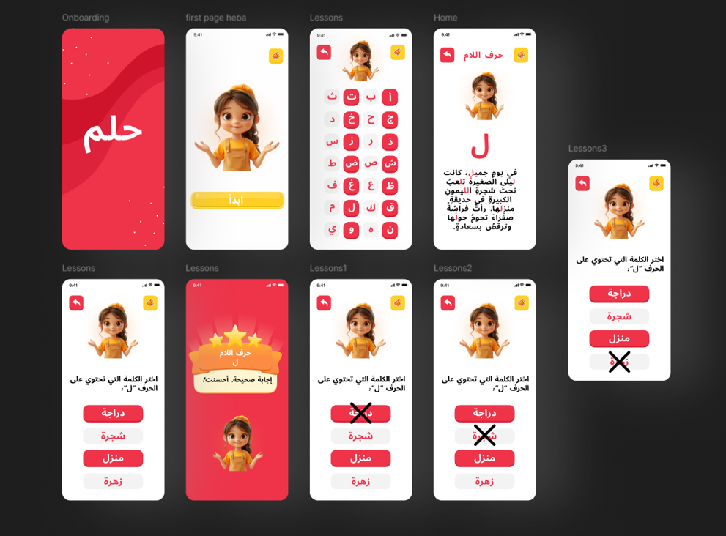

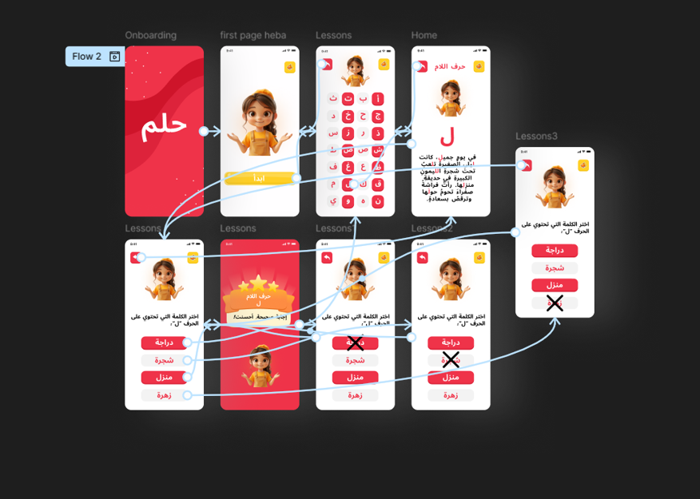

**10. Expected Output**

Upon completion, "Hulum" should offer:

* A MVP functional user Interface.
* AI-generated stories and exercises correctly

**11. Future Considerations**

Looking ahead, the project will expand by introducing more advanced language levels as children progress, enabling parents to customize the app to suit their child’s learning needs, offering detailed progress reports for teachers and parents, and implementing a reward system with virtual prizes to motivate children as they advance through language levels.

**12. Conclusion**

The "Hulum" app is an innovative solution designed to make Arabic language learning engaging and accessible for young children. By integrating AI-based content generation with interactive stories and exercises, "Hulum" provides a personalized learning experience tailored to each child's progress. The app’s design focuses on creating a child-friendly and intuitive interface, ensuring that children remain motivated and engaged throughout their learning journey. Despite some limitations, such as age and content restrictions, the app has the potential to expand in the future to include more advanced content levels, and enhanced reporting features. By combining educational content with interactive elements, "Hulum" not only enhances language skills but also builds children’s confidence and cognitive abilities. Ultimately, the app aspires to make Arabic language learning accessible, enjoyable, and efficient, setting a new standard for early childhood language education.